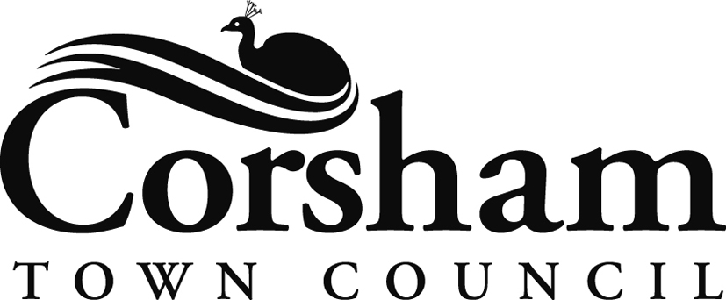

Town Hall, High Street, Corsham, Wiltshire SN13 0EZ

Tel: 01249 702130 Email: towncouncil@corsham.gov.uk www.corsham.gov.uk

7 July 2020

To: All Members of Corsham Town Council as Trustees of The Methuen (Town) Hall

Dear Councillor

The Methuen (Town) Hall – Registered Charity No 222278

The next meeting of the Charity will be held on Monday 13 June 2020 via MS Teams, commencing at the rise of the Meeting of Corsham Town Council, which is to be held earlier in the evening.

Yours sincerely

David J Martin
CHIEF EXECUTIVE

AGENDA

- Apologies

- Declarations of Interest

To receive any Declaration(s) of Interest under Corsham Town Council’s Code of Conduct issued in accordance with the Localism Act 2011.

- Minutes of the Meeting of the Trustees held on 9 March 2020 – attached.

- Matters Arising from the above Minutes – for information only.

- Independent Examiners Report and Accounts for 2019/20 – a copy of the report and accounts are attached for approval.

- Authorisation of Cheques and Payments - The lists of payments made in April, May and June are attached – for approval.

Invoices for Payment - Methuen Hall 14 April 2020
Online Banking Payments
Name
Corsham Town Council – Cleaning Town Hall | £456.36
Standbrook Guides - Town Hall Advertising | £270.00
Geze - Automatic Door Service | £174.00
Cathedral Leasing Ltd - Hygiene Services | £182.52
Cheques
There are none
Sub-total | £1,082.88
Cheques / IB Transfers Paid Outside of Meeting
There were none
Payments made by Direct Debit
Wiltshire Council – Non-Domestic Rates | £192.00
West Mercia Energy - Electricity | £342.06
Hills Waste Solutions Ltd - Duty of Care Annual Charge | £9.60
Water to Business - Town Hall Water Usage | £228.15
Sub-total | £771.81
TOTAL | £1,854.69

Invoices for Payment - Methuen Hall 12 May 2020
Online Banking Payments
Name
Corsham Town Council – Cleaning Town Hall | £456.36
Dentons Directory - Advertising Town Hall as a Venue | £108.00
Zurich Insurance - Annual Lift Insurance | £3,111.65
Cheques
There are none
Sub-total | £3,676.01
Cheques / IB Transfers Paid Outside of Meeting
There were none
Payments made by Direct Debit
Wiltshire Council – Non-Domestic Rates | £0.00
West Mercia Energy - Gas | £299.90
Hills Waste Solutions Ltd - Duty of Care Annual Charge | £9.60
Sub-total | £309.50
TOTAL | £3,985.51

Invoices for Payment - Methuen Hall 8 June 2020
Online Banking Payments
Name
Corsham Town Council - Cleaning Town Hall | £456.36
IWS - Water Hygiene Services - March and May | £392.91
Kone - Lift Repair | £373.04
Cheques
There are none
Sub-total | £1,222.31
Cheques / IB Transfers Paid Outside of Meeting
There were none
Payments made by Direct Debit
Wiltshire Council – Non-Domestic Rates | £0.00
West Mercia Energy - Gas | £230.14
West Mercia Energy - Electricity | £291.10
Hills Waste Solutions Ltd - Duty of Care Annual Charge | £9.60
Sub-total | £530.84
TOTAL | £1,753.15

