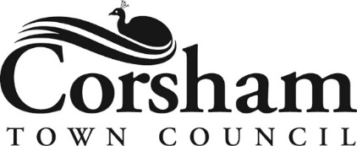
Sustainable Procurement and Investment Policy
December 2022
This sustainable procurement and investment policy places a clear focus on sustainability and our environmental impact on everything we purchase. Corsham Town Council recognises that improving our procurement performance is an ongoing process. It will take time to become fully sustainable and will require working in partnership with all our suppliers and contractors.
Procurement:
- Ensure all staff are trained to make a conscious effort to only choose suppliers who demonstrate a commitment to reducing their impact on climate change through their business operations.
- Ensure all staff are trained to implement best practice for sustainable purchasing.
- Ensure the supply chain of any goods and services purchased by the Town Council is as climate-friendly as possible.
- Request industry standards/accreditation and an Environment Policy from all contractors and companies used by the Town Council to ensure they are operating as sustainably as possible.
- Ensure suppliers and contractors are aware of the Town Council’s Environmental Policy by providing a copy or link to the information on our website.
- Work in partnership with our current suppliers and support them to continually improve our collective sustainability performance.
- Assess and review the sustainability risks and impacts of the products and services the Town Council purchases.
- Use lifecycle analysis to evaluate the environmental impacts associated with all the stages of the life cycle of a product or service before purchasing. Aim to achieve closed-loop recycling rather than wasting materials at the end of use. Closed loop recycling is the process by which recycled waste is processed and re-purposed to create new items.
- Wherever possible use local suppliers and contractors over national or international companies to reduce the mileage of products and services we purchase.
- Use and dispose of all goods in an environmentally responsible way by reducing materials, substituting for environmentally friendly materials, reusing and recycling materials.
Investment:
- Review all Town Council investments for zero-carbon compliance. It is crucial that the Town Council understands where its money is and whether it is exposed to climate risk, and the 'stranded assets' of fossil fuel companies.
- Divest all investments from fossil fuels.
- Encourage Wiltshire Pension Fund, of which most staff are members, to set ambitious targets for reaching net zero carbon. The current goal is “to protect the investments from climate risk, and safeguard the financial future of the Fund.” The Fund’s carbon footprint has reduced by 19% from 31st December 2019 to 31st December 2021.
- Offer grants towards carbon reduction projects in the town.
November 2022

(Approved by Finance and Administration Committee December 2022)

